***Retina-on-a-chip – Development of a parallelized microphysiological system amenable for high-content drug testing.***

***Team Lead***

**Prof. Dr. Katja Schenke-Layland**

Fraunhofer Institute for Interfacial Engineering and Biotechnology IGB Director (executive, acting)

Nobelstrasse 12, 70569 Stuttgart, Germany

Phone +49 711 970-4082 | Fax +49 711 970-4200

[katja.schenke-layland@igb.fraunhofer.de](mailto:katja.schenke-layland@igb.fraunhofer.de)

[www.igb.fraunhofer.de](http://www.igb.fraunhofer.de)

Dept. of Women’s Health, Research Institute for Women’s Health

Eberhard Karls University Tübingen

Silcherstr. 7/1, 72076 Tübingen, Germany

Phone: +49-7071-29-85205

E-Mail: [katja.schenke-layland@med.uni-tuebingen.de](mailto:katja.schenke-layland@med.uni-tuebingen.de)

[www.schenke-layland-lab.com](http://www.schenke-layland-lab.com)

Department of Medicine/ Cardiology

Cardiovascular Research Laboratories (CVRL)

University of California Los Angeles (UCLA)

675 Charles E. Young Drive South, MRL 3645

Los Angeles, CA, 90095-1760

***Team members***

**Prof. Dr. med. Stefan Liebau**

Institute of Neuroanatomy & Developmental Biology

Eberhard Karls University Tübingen

Österbergstr. 3

72074 Tübingen, Germany

[stefan.liebau@uni-tuebingen.de](mailto:stefan.liebau@uni-tuebingen.de)

**Dr. Peter Loskill**

Fraunhofer Institute for Interfacial Engineering and Biotechnology IGB

Department of Cell and Tissue Engineering

Attract Group Manager Organ-on-a-Chip

Nobelstrasse 12, 70569 Stuttgart, Germany

Phone +49 711 970-3531 | Fax +49 711 970-4200

[peter.loskill@igb.fraunhofer.de](mailto:peter.loskill@igb.fraunhofer.de)

[www.igb.fraunhofer.de](http://www.igb.fraunhofer.de)

**Comprehensive Description of the Proposed Solution**

***Abstract:*** *We have developed a prototype of a human induced pluripotent stem cell (hiPSC) based 3D Retina-on-a-chip challenging several current disadvantages of stem cell based in vitro systems. It allows for 3D co-culture of retinal organoids, retinal pigment epithelium (RPE) and further cell types in a defined and reproducible microenvironment, featuring a physiological vasculature-like perfusion. The system enables the maintenance of viability and functionality of the retinal 3D tissue over multiple weeks. Moreover, our first results indicate a substantial improvement of photoreceptor outer segment formation and a functional interplay of photoreceptor and RPE as shown by segment phagocytosis. In the framework of the 3-D ROC Challenge, we propose a parallelization of our 3D Retina-on-a-chip system and the integration of further hiPSC-derived cell types (e.g. endothelial cells) to create a next generation Retina-on-a-chip 2.0 system. The Retina-on-a-chip 2.0 will feature 48 individual units in an integrated chip with standard well plate-dimensions and will be amenable for high content drug screening as well as disease modeling.*

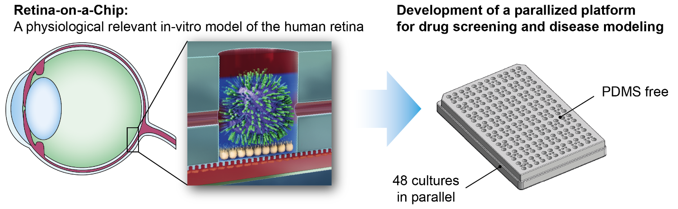

The human retina *in situ* is hardly accessible for molecular investigations. To investigate cellular interactions, signaling cues and the impact of therapeutic approaches, a complete retinal niche is required. Current stem cell-based research on the human retina therefore strives to develop highly reproducible and accessible systems that provide a bona fide model in close proximity to the *in vivo* situation. Nevertheless, human induced pluripotent stem cell (hiPSC) derived retinal cell subtypes and **3-dimensional organ-like structures (organoids) are still facing a variety of drawbacks**. Restrictions such as insufficient maturation, inadequate physiological interplay between retinal cells, and the lack of an optic nerve-like structure representing the projection of the retinal ganglion cells limit precise research on e.g. human retinal development, function or drug response. Additionally, those models suffer from general limitations of static well plate culture, such as non-physiological cell/media ratio and uncontrolled, highly variable conditions in-between media exchanges.

In general, it is envisioned that **physiologically relevant, vascularized 3D *in vitro* tissue models will change the landscape of drug screening applications**. A promising approach to generate such microphysiological 3D tissue models is the combination of advanced microfluidic platforms with hiPSC-based tissue engineering. A unique aspect of those so-called Organ-on-a-chip (OoC) systems is the physiologically relevant microfluidic environments that allow for the control of nanoliter fluid volumes and flows, enabling recapitulation of native physiological niches. The OoC approach offers a number of advances including: unprecedented control over fluid flow mimicking *in vivo* diffusive properties; compatibility with high content drug screening; miniaturization of large systems for convenient operation; significant reduction of expensive cell reagents; potential for parallelization, and connection with other organ-chips.

Our approach to address the ***NEI 3-D Retina Organoid Challenge* is based on a 3D *Retina-on-a-chip*** platform featuring a perfused microphysiological environment generated by the combination of advanced microfluidic OoC technology with tailored hydrogels and hiPSC-derived cells.

**Preliminary work:** To generate retinal organoids, which comprise all cell types abundant in the physiological retina and gain function in terms of light sensitivity, we have **developed an optimized differentiation protocol** based on previous publications (Zhong et al., 2014). The retinal organoids feature all sensory, interconnecting and stimulus conducting neuronal subtypes as well as Müller glia. The protocol, furthermore, enables the organoids to mature and survive for > 250 days *in vitro*. Additionally, we established **SOPs for the reproducible generation of high quality retinal pigment epithelial** (RPE) cells from hiPSCs and gained broad experience in vasculo- and angiogenesis *in vitro*.

In order to provide a physiological niche for retinal cells we developed a **microphysiological *Retina-on-a-chip* system, which allows a co-culture of hiPSC-derived 3D retinal organoids and RPE cells embedded in a hyaluron-based hydrogel and integrated in a vasculature-like perfusion (Fig. 1a)**. For initial experiments, we designed two separate chips, an RPE chip and an organoid chip. HiPSC-derived RPE cells cultured in the RPE chip revealed typical cobblestone morphology (Fig. 1b) and specific RPE marker proteins (MiTF, ZO-1, RPE65) similar to classical dish culture (Fig.1c). To assess the maturity of RPE cells, qPCR array analysis was performed with corresponding RPE marker genes (Fig.1d). Retinal organoids of different age (80, 190, and 400 days) were successfully cultured inside the organoid chip for more than three days without any loss of morphology or signs of degeneration (Fig.1e). In the second step, we established a stable co-culture of RPE cells and retinal organoids in the combined *Retina-on-a-chip*. By injection of hyaluron-based hydrogels into the chip that resemble the interphotoreceptor matrix, a defined distance between RPE cells and retinal organoids was achieved. Co-cultures were maintained in the chip for more than seven days, while viability was monitored continuously via live cell imaging, using fluorophore-tagged RPE cells, and via fluorophore coupled PNA lectin-marked organoid photoreceptor segments (Fig.1g). Reconstruction after seven days showed a close apposition and interaction between the two structures (Fig.1f). After seven days of culture with and without RPE, we retrieved organoids from the chip and revealed the preservation of key morphologic characteristics via electron microscopy (Fig.2a), mRNA transcription levels (Fig.2b), and immunofluoresence (Fig.2c). Organoids-RPE co-culture showed presence of expected cells types but no signs of glia activation or apoptosis. Interestingly, at the side of the organoid facing the RPE layer, large outgrowing outer segment-like structures were observed, which stained positive for Rhodopsin and the outer segment marker Peripherin 2 (Fig.2d). These structures were not present at the non-RPE side (Fig.2e), neither in organoids cultured in the chip without RPE nor in a normal dish culture (data not shown).

To further assess functionality and physiological accuracy of the *Retina-on-a-chip*, we performed calcium imaging showing spontaneous calcium flux inside photoreceptor cells (Fig.2f) and established a phagocytosis assay showing the shedding and uptake of organoid photoreceptor outer segments (POS) (Fig 3.a-d). Initially, phagocytosis activity of RPE cells was successfully confirmed by applying bovine POS to dish-culture - staining early endosomes (EEA1) and for Rhodopsin (Fig.3a). In the *Retina-on-a-chip*, PNA lectin marked segments of retinal organoids were phagocytosed by RPE cells visualized by lectin (Fig.3b) and Rhodopsin staining (Fig.3c), and live cell monitoring of the phagocytosis process (Fig.3d). To increase the usability of our system we established the following *in situ* analysis methods: a) A passive clearing technique to render the organoids transparent and thus, enabling whole organoid - RPE staining *in situ* (Fig.3e); b) Promoter driven fluorophore-labeled cell lines (photoreceptors, retinal ganglion cells, activated glia), enabling live cell imaging inside the *Retina-on-a-chip* (Fig.3f). Additionally, we used fluorophore coupled PNA lectin to visualize the outgrowth of inner and outer segment of retinal organoids, enabling continuous and non-invasive monitoring for more than 24 hours and 3D-reconstruction by confocal microscopy (Fig.3f).

**As a proof of concept compound screening,** we applied **Vigabatrin (VB),** a GABA transaminase inhibitor, for 20 days to retinal organoids and monitored structural and functional changes. We could not observe any changes in glia proliferation or structural aberrations of photoreceptors (Fig.4a). To test the electrophysiological impact of VB, we treated organoids for 11 days in the dark and in presence of light (Fig.4b). Calcium imaging indicated an increased activity in the presence of VB with light. Acute treatment of organoids with VB led to an increase in spontaneous calcium activity in multiple cells (Fig.4c). Additionally, we applied **Chloroquine**, an anti-malaria drug with known retinopathic side effects, to RPE cells off and on-chip. As expected (Chen, Gombart, & Chen, 2011), a vacuolization related to lysosome dilatation was observed in all conditions, shown by immunofluorescence staining against Lamp2 as lysosomal marker (Fig.4d-e).

In summary, our *Retina-on-a-chip* prototype provides a **novel physiological relevant *in vitro* representation of the retinal system**, which is not only amenable for drug screening but also allows for developmental studies on, for instance, RPE-photoreceptor interactions.

**Proposed development:** For a successful adoption as a drug screening platform, it is of upmost importance to develop an integrated system with a significant increased predictive value, which also enables the screening of a sufficient number of parameters (compounds, concentrations, stress factors, cells). In the framework of the *NEI 3-D Retina Organoid Challenge*, we plan to i) further increase the physiological relevance of our system by incorporating additional cell types, ii) to increase the ease of use as well as throughput by parallelization and incorporation in automated work flows, and iii) to validate the system using a training set of compounds.

In terms of **technical enhancement, the proposed system will be a highly parallelized platform** amenable for both high-content as well as medium-throughput experimentation. Moreover, the system needs to consist of an inert material, be user-friendly and compatible with standard laboratory equipment. Using a combination of 3D printing and laser cutting, we will fabricate a next-generation chip consisting of mainly cyclic olefin copolymer (COC). By multiplexing the individual *Retina-on-a-chip* units from our established prototypes, we will generate a system that features about 48 individual modules on a footprint of a standard multi-well-plate. Systems with different flow architectures will thereby enable either the variation of media composition for each individual unit or the exposure of multiple biological replicates to the same conditions. To increase the ease of use, we will optimize SOPs for compatibility with automated liquid handling systems and implement two types of media perfusion based on either specific adapters for pumps or gravitational flow.

In terms of **biological enhancement, we will increase the physiological relevance by incorporating hiPSC-derived endothelial cells** and further cell types into the chip. We recently started the establishment of an endothelial and pericyte cell differentiation protocol based on a protocol by Yamamizu et al. (Yamamizu et al., 2017). The protocol was shown to give rise of nearly 99% CD31/VE-Cadherin positive endothelial cells after 9 days. For use in the *Retina-on-a-chip* this purity could be even increased using CD31+ labelled cell sorting. Subsequently, these cells will be cultured on the media channel side of the thin porous membrane adjacent to the RPE cells, mimicking a choroid-RPE connection side (Fig 1a). This will not only further increase the physiological relevance and predictive value of the *Retina-on-a-chip* but also extend its usability for drug screening and disease modelling questions towards the pathophysiology and treatment of macular edema (ME). As a proof of concept, we will apply VEGF, a known trigger for ME, and other ME-inducing drugs (cf. Table 1).

In terms of **validation of the *Retina-on-a-chip*, we will perform an in-depth functional and morphological characterization as well as compound screening** to gain a precise knowledge of predictive value as well as limitations of the platform. First, we will perform mechanistic studies making use of the various developed endpoints. For instance, we will test the benefit of the in-chip conditions by monitoring pH and the retinal metabolism e.g. glucose in comparison to classically dish- cultured organoids. Second, we will perform further calcium imaging studies to study the light sensitivity of photoreceptors in the *Retina-on-a-chip*. Third, we will set up a quality assessment of retinal organoids of various time points in order to ensure reproducibility of our system. As quality biomarkers we will monitor a) microscopic layering of the organoid including the appearance of segment structures, b) the amount and organization of photoreceptors marked with fluorophore tags (as seen in fig 3f), c) the occurrence of degeneration signs such as holes or cell debris inside and outside the organoid, and d) excessive occurrence of unwanted RPE cells. To validate the **predictive value of the *Retina-on-a-chip* and applicability as a drug screening** platform, we will screen a training set of compounds with known ocular side effects that are on the market. A list of suggested drugs is provided in Table 1. The proposed substances cause a variety of syndromes which we believe to be reproducible in our system especially retinopathy and choroid edema. To assess inter-laboratory reproducibility, the compound screening will be performed at the different lab sites of the team members.

**Table 1**: Training set of compounds for the validation of the *Retina-on-a-chip* system

|  |  |  |
| --- | --- | --- |
| **Drug** | **Use** | **Ocular side effects** |
| Chloroquine | Malaria, Autoimmune diseases | blurred vision, decreased vision, scotomas and photopsias |
| Hydroxychloroquine | Malaria, Autoimmune diseases | blurred vision, decreased vision, scotomas and photopsias |
| Thioridazine | Antipsychotic | decreased vision and dyschromatopsia |
| Deferoxamine | Excessive serum iron levels, aluminium toxicity | vision loss, scotomas, dyschromatopsia, and nyctalopia |
| Tamoxifen | Breast cancer | decreased vision and dyschromatopsia |
| Canthaxanthine | Psoriasis, eczema | decrease in retinal sensitivity |
| Talc | Oral powdered medications (LT Drug Abuse) | severe, progressive vision loss |
| Latanoprost | Lower IOP | reversible cystoid macular edema, conjunctival hyperemia, darkening of eyelashes and iris heterochromia |
| Niacin (Vit B3) | Pellagra, hyperlipidemia, hypercholesterolemia | blurred vision, decreased vision and metamorphopsia |
| Fingolimod | Multiple sclerosis | macular edema |
| Digoxin | atrial fibrillation, atrial flutter and congestive heart failure | decreased vision to photopsias, xanthopsia and scotomas |
| ATP | Retinal Degeneration model | Induce PRC death |

**Innovation statement:** Human pluripotent stem cell derived 3-D organ-like structures (organoids) have been shown to reflect distinct tissues such as subsystems of the central nervous system including the retina. Retinal organoids, also called “eyes in the dish” resemble rudimentary eyecup like structures with a retinal layering close to the physiological conditions. These organoids contain all relevant retinal cells such as ganglion cells, amacrine cells, horizontal cells, bipolar cells, Müller glia as well as rods and cones. This system represents a unique tool to investigate human as well as individual retinal development and function, respectively. Apart from stem cell derived retinal organoids, the only other human system *in vitro* is represented by retinal explants, either from deceased persons or from retinal surgeries. Human retinal explants are, nevertheless, a system with multiple disadvantages. First, these explants are very rare and availability is very unpredictable. Experimental settings are therefore almost not feasible. Moreover, these explants can only be cultured for a few weeks. Apart from these two systems, all other models are either not human (mice, Drosophila, Danio Rerio etc.) or cannot reflect the system of the retina itself (cell lines).

Our approach brings together expertise and methodologies from multiply different disciplines by integrating microfabrication, tissue engineering, stem cell technology, and retinal pathobiology. Based on this interdisciplinary framework, we combine existing and published retinal organoid cultures with a **unique microphysiological system (*Retina-on-a-chip*) allowing for an organotypic culture with improved maturation**. The *Retina-on-a-chip* system is compatible with live cell visualization and allows access for precise fluid supplementation and exchange. The highly controlled, reproducible and parallelizable co-culture system integrating cells of interest is the main innovation in our challenge approach as it provides the potential to answer developmental, functional as well as pathomechanistical questions in the human retina. To our knowledge, there is currently no microfluidic system available that can provide the same or comparable features as our developed *Retina-on-a-chip* prototype. The platform shows the potential **to increase the photoreceptor and overall retina differentiation to a so far unreached state** by providing a physiological RPE-PRC inner and outer segment interplay, a continuous media flow mimicking the physiological vascularization, a blood retina barrier as well as a interphotoreceptor matrix. **This makes our system amenable for questions which cannot be faced by classical *in vitro* models or retinal organoids such as the secondary effects of degenerating RPE cells on photoreceptor cells**.

One of the limitation of the current Retina-on-a-chip is that up to now it cannot solve the lack of a optic nerve as well as the occurrence of ganglion cell degeneration. However, ideas and concepts adressing this limitation have already been developed and it is intended to implement those in future generations. A further potential pitfall and general limitation of complex organ-on-a-chip systems, is that the handling is significantly more complex compared to standard cell culture and requires specific training. To counter this and increase the ease of use, we will optimize SOPs for compatibility with automated liquid handling systems and implement two types of media perfusion based on either specific adapters for pumps or gravitational flow as well as set up content for specific training sessions

**Biographical Sketches**

The *Retina-on-a-chip* team comprises three PIs, namely Prof. Dr. Katja Schenke-Layland (team lead), an expert in developmental and stem cell biology, Prof. Dr. med Stefan Liebau, an expert in retinal biology, and Dr. Peter Loskill, an expert in microfluidic organ-on-a-chip development.

|  |  |  |  |
| --- | --- | --- | --- |
| NAME  **Katja Schenke-Layland** | POSITION  **Professor of Medical Technologies and Regenerative Medicine** | | |
| EDUCATION/ TRAINING | | | |
| **INSTITUTION AND LOCATION** | **DEGREE(s)** | **YEAR(s)** | **FIELD(s) OF STUDY** |
| UCLA, Cardiovascular Research Laboratories & Children’s Hospital, Los Angeles/CA, USA | Postdoctoral Research Fellow | 2004-2008 | Stem Cell Research/ Cardiovascular Tissue Engineering |
| Friedrich Schiller University (FSU) Jena, Germany | Dr. rer. nat. | 2001-2004  (23.9.2004) | Biology/ Cardiovascular Tissue Engineering |
| Friedrich Schiller University (FSU) | M.Sc. | 1995-2000 | Biology, Sociology, Psychology |

**Professional Experience:**

01/16-present **Director** (interim, executive), Fraunhofer IGB, Stuttgart, Germany

04/13-present **Department Head**, Fraunhofer IGB, Dept. of Cell and Tissue Engineering

11/11-present **Full Professor (W3)**, Eberhard Karls University Tübingen (EKUT), Dept. of Women’s Health, Research Institute for Women’s Health, Tübingen, Germany

11/13-present **Adjunct Associate Professor**, University of California Los Angeles (UCLA), Dept. of Medicine/ Cardiology, Los Angeles, CA, USA

01/10-03/13 **Group Leader**, Fraunhofer IGB, Dept. of Cell and Tissue Engineering

11/08-12/09 **Assistant Research Professor**, UCLA, Dept. of Medicine/ Cardiology, Cardiovascular Research Laboratories

**Selected Publications:**

* N. Shen, …, **K. Schenke-Layland**. “Steps towards maturation of embryonic stem cell-derived cardiomyocytes by defined physical signals“, *Stem Cell Reports* **9**, 122-135 (2017)
* A. Hoppensack, …, **K. Schenke-Layland**. “A Human In Vitro Model That Mimics the Renal Proximal Tubule”, *Tissue Eng Part C Methods* **20**, 599-609 (2014)
* E. Brauchle, H. Johannsen, S. Nolan, S. Thude, **K. Schenke-Layland**. „Design and analysis of a squamous cell carcinoma in vitro model system”, *Biomaterials* **34**, 7401-07 (2013)
* J. Pusch, …, **K. Schenke-Layland**. The physiological performance of a three-dimensional model that mimics the microenvironment of the small intestine”, *Biomaterials* **32**, 7469-7478 (2011)
* **K. Schenke-Layland** *et al.* „Reprogrammed mouse fibroblasts differentiate into cells of the cardiovascular and hematopoietic lineages”, *Stem Cells* **26,** 1537-1546 (2008)

|  |  |  |  |
| --- | --- | --- | --- |
| NAME  **Stefan Liebau** | POSITION  **Director of the Institute of Neuroanatomy** | | |
| EDUCATION/ TRAINING | | | |
| **INSTITUTION AND LOCATION** | **DEGREE(s)** | **YEAR(s)** | **FIELD(s) OF STUDY** |
| Ulm University, Institute of Anatomy & Cell Biology, Ulm | Postdoctoral Research Fellow | 2004-2013 | Stem Cell Research, Neuroscience |
| Ulm University, Department of Neurology, Ulm, Germany | MD | 2001-2003 | Experimental Neurology |
| Ulm University, Ulm, Germany |  | 1993-2000 | Human Medicine |

**Professional Experience:**

10/13-present **Director**, Insitute of Neuroanatomy & Developmental Biology, Eberhard Karls University Tübingen, Germany

**Selected Publications:**

* M. Hohwieler, …, **S. Liebau\***, A. Kleger*. „Human pluripotent stem cell-derived acinar/ductal organoids generate human pancreas upon orthotopic transplantation and allow disease modelling”, *Gut* **66**, 473-486 (2016)
* R. Russell, …, **S. Liebau\***, A. Kleger*. „A Dynamic Role of TBX3 in the Pluripotency Circuitry”, *Stem Cell Reports* **5**, 1155-1170 (2015)
* Weidgang CE, …, **S. Liebau\***, A. Kleger*. „TBX3 Directs Cell-Fate Decision toward Mesendoderm”, *Stem Cell Reports* **1**, 248-65 (2013)
* L. Linta, …, **S. Liebau**. „Rat embryonic fibroblasts improve reprogramming of human keratinocytes into hips cells”, *Stem cells and Development* **21**, 965-976 (2012)
* M. Stockmann, …, **S. Liebau \***, Boeckers TM*. „Developmental and functional nature of human ipsc derived motoneurons”, *Stem Cell Rev.* **9**, 475–492 (2013).

|  |  |  |  |
| --- | --- | --- | --- |
| NAME  **Peter Loskill** | POSITION  **Attract Group Leader Organ-on-a-chip** | | |
| EDUCATION/ TRAINING | | | |
| **INSTITUTION AND LOCATION** | **DEGREE(s)** | **YEAR(s)** | **FIELD(s) OF STUDY** |
| University of California at Berkeley, Berkeley/CA, USA | Postdoctoral Researcher | 2013-2016 | Bioengineering, Tissue engineering, Organ-on-a-chip |
| Saarland University, Saarbrücken, Germany | Dr. rer. nat. | 2009-2012  (29.10.2012) | Biophysics, Bioadhesion, Biointerfaces |
| Saarland University, Saarbrücken | M.Sc. | 2004-2009 | Physics, Mathematics, Biology |

**Professional Experience:**

03/16-present **Fraunhofer Attract Group Leader,** Fraunhofer IGB, Stuttgart, Germany

11/14-01/16 **Project Leader,** Tissue Chip for Drug Screening project, Dept. of Bioengineering, University of California at Berkeley, Berkeley, CA, USA

**Selected Publications:**

* **P. Loskill**, *et al.* “WAT-on-a-chip: A physiologically relevant microfluidic system incorporating white adipose tissue”, *Lab Chip* **17**, 1645-1654 (2017)
* **P. Loskill\***, S. G. Marcus, A. Mathur, W. M. Reese, K. E. Healy. “μOrgano: A Lego-Like Plug & Play System for Modular Multi-Organ-Chips“, *PLOS ONE* **10**, e0139587 (2015)
* Mathur, **P. Loskill** *et al.* “Human iPSC-based Cardiac Microphysiological System For Drug Screening Applications“,*Sci.* *Rep*. **5**, 8883 (2015)
* H. Jeon, S. Koo, W. M. Reese, **P. Loskill**, C. P. Grigoropoulos, K. E. Healy “Directing cell migration and organization via nanocrater-patterned cell-repellent interfaces.“, *Nat. Mater***. 14,** 918–923 (2015)
* **P. Loskill**, H. Hähl, T. Faidt, S. Grandthyll, F. Müller, K. Jacobs**.** “Is adhesion superficial? Silicon wafers as a model system to study van der Waals interactions“, *Adv. Colloid Interface Sci.* **179-182**, 107-113 (2012).

**Feasibility Assessment**

To conduct this proposal, we have gathered a **team that combines expertise in engineering, bio-engineering, commercialization and organoid biology** led by Prof. Dr. Katja Schenke-Layland. The fusion of both biological and technical skills is a prerequisite to construct, use and improve the microfluidic device (***Retina-on-a-chip***) as proposed in our study. The combined effort of the research members in the group has already paved the way for the development of a *Retina-on-a-chip* (True-Retina) system allowing for defined co-culture of hiPSC-derived retinal pigment epithelial cells together with well-stratified and functional retinal organoids comprising all neural retina cell subtypes under full control. Additionally, a blood-vessel-like media flow chamber for the nutrition of the RPE cells is covered by hiPSC derived endothelial cells to mimic the blood retina barrier.

We have tested the feasibility of the *Retina-on-a-chip* using our own hiPSC-derived organoids and RPE cells in our well-established laboratory. HiPSC derived endothelial cells are momentarily generated. The development of a highly parallelized *Retina-on-a-chip* in a standard multi-well plate format with a broad methodical accessibility of live- and endpoint analyses is now of high priority in the team. This circumstance will make it possible to address the deliverables in the given period. Fabrication of the systems, culture test settings as well as methods of live- and end-point analyses are well established in the groups.

**Preliminary evaluation of the in-chip co-cultured RPE cells and retinal organoids prove the existence of all five neural cell subtypes of the retina plus Müller glia**. This can be shown (i) via end-point analysis using cryosections after removal of the organoids from the *Retina-on-a-chip* or (ii) directly via promotor-reporter fluorescence using established constructs for photoreceptors, ganglion cells or Müller glia (reporter constructs for horizontal or amacrine cells are developed). We could not detect other cell types in our retinal organoids and the RPE is of highest purity. Of note, our defined and controllable co-culture of the organoid with RPE shows a yet unpublished functionality proven by the phagocytosis of outer segments by RPE cells, both derived from hiPSCs. The orientation of the organoids and RPE cells is given by the structure of the *Retina-on-a-chip* and the pre-cultivation of the 3D organoids under conditions adopted from Zhong et al. allow for a reproducible generation of high numbers of organoids. Cultivation in-chip may be started at different time-points of organoid maturation and with or without initial RPE presence.

Our microfluidic approach provides a system with continuous media supply, resulting in a conditioned and perfect surrounding for long-term survival. Moreover, the co-culture of organoid plus RPE with a defined distance more closely mimics the retina *in vivo* and first results give evidence that the RPE layer protects the PRC layer at the organoid side in comparison to the averted side of the organoid devoid of RPE contact. **Together, we are already able to extend the period of viable co-cultures in-chip compared to conventional non-chip co-cultures.** We aim to improve the *Retina-on-a-chip* culture in order to provide an environment that allows for a long-term co-culture for up to 1 year. In case that cultures stay viable and show ongoing maturation this system would provide a highly advanced platform to study the human retina. Moreover, toxicity screens and search for new drugs requires a human model that is more than solely a rudimentary embryonic retina precursor.

The system has been tested for transferability to other laboratories. The *Retina-on-a-chip* loaded with all required cell types/organoids survives at simple packaging for up to one day off the incubator without showing significant degeneration of cells. The system is accessible for several functional assays including calcium imaging to investigate neuronal function and conduction. Furthermore, live-cell imaging in-chip allows for investigations of e.g. the “blood-retina barrier, RPE phagocytosis of outer PRC segments or cell morphology.

All procedures including the loading of the *Retina-on-a-chip*, incubation, observation, nutrition and preparation of end-point analyses will be provided as SOP protocols. The usage of the Retina-on-a-chip is simple and allows a high reproducibility of conducted experiments.

**A highly parallelized system of defined and controllable culture chambers represents a prerequisite for high-throughput analyses**. The expansion of our current system to a multi-chamber device is achievable in the given period and variations of the product are possible:

* Multiwell-format with individual in and outlet of media
* Multiwell-format with several wells interconnected

A variable culture w/o individual cell types is also possible. The multi-well format is usable for automated live-cell observations using commercially available microscope formats. We can also provide a number of SOPs for in-chip analyses or end-point analyses following retrieval of the cells from the device.

**For the recapitulation of the effect of known compounds on retinal cells and to verify these results in our hiPSC-based *Retina-on-a-chip,* we have already tested substances with a known effect in our system**. We can provide data recapitulating the effect of the substance Chloroquine on in-chip co-cultured RPE cells. Ongoing studies in our team investigate a variety of chemical compounds known to have an impact on retinal degeneration. The substances to be tested may be administered either from the (blood-vessel-like) canal below the RPE or more directly to the organoid via the organoid loading tube. Notably, the concentration of the compound can be held at constant concentrations given the continuous liquid flow in the *Retina-on-a-chip*

From the technical point of view, we are able to reach our goals in the given time and in close discussion with the NEI we may even add new features to the system.

All human induced pluripotent stem cells have been generated from hair keratinocytes. Hair have been plucked from voluntary donors after given informed consent. All cell lines have been anonymized before cultivation and differentiation. The use of hiPSCs for this study has been approved by the local ethics committee at Tübingen University. After a possible commercialization, a product can be sold with hiPSC derivatives from commercially available cell lines. In a given case of transferring an empty *Retina-on-a-chip* device, the conducting laboratory is responsible for the utilization of their cells.

|  |  |  |  |  |  |  |  |  |  |  |  |  |  |  |  |  |  |  |
| --- | --- | --- | --- | --- | --- | --- | --- | --- | --- | --- | --- | --- | --- | --- | --- | --- | --- | --- |
| **Quarter**  **Workpackage** | ***1*** | | | ***2*** | | | ***3*** | | | ***4*** | | | ***5*** | | | ***6*** | | |
| Transition to non-PDMS chip materials |  |  |  |  |  |  |  |  |  |  |  |  |  |  |  |  |  |  |
| Parallelization of 24 *Retina-on-a-chip* units per platform |  |  |  |  |  |  |  |  |  |  |  |  |  |  |  |  |  |  |
| Parallelization of 48 *Retina-on-a-chip* units per platform |  |  |  |  |  |  |  |  |  |  |  |  |  |  |  |  |  |  |
| Implementation of multiple perfusion systems & controls |  |  |  |  |  |  |  |  |  |  |  |  |  |  |  |  |  |  |
| Establishment of hiPSC-endothelial cell generation |  |  |  |  |  |  |  |  |  |  |  |  |  |  |  |  |  |  |
| Integration of endothelial barrier in *Retina-on-a-chip 2.0* |  |  |  |  |  |  |  |  |  |  |  |  |  |  |  |  |  |  |
| Mechanistic studies using the  *Retina-on-a-chip 2.0* |  |  |  |  |  |  |  |  |  |  |  |  |  |  |  |  |  |  |
| Screening of training compound set |  |  |  |  |  |  |  |  |  |  |  |  |  |  |  |  |  |  |
| Consolidation of SOPs and training content |  |  |  |  |  |  |  |  |  |  |  |  |  |  |  |  |  |  |

**References**

Chen, P. M., Gombart, Z. J., & Chen, J. W. (2011). Chloroquine treatment of ARPE-19 cells leads to lysosome dilation and intracellular lipid accumulation: possible implications of lysosomal dysfunction in macular degeneration. *Cell Biosci, 1*(1), 10. doi:10.1186/2045-3701-1-10

Yamamizu, K., Iwasaki, M., Takakubo, H., Sakamoto, T., Ikuno, T., Miyoshi, M., . . . Yamashita, J. K. (2017). In Vitro Modeling of Blood-Brain Barrier with Human iPSC-Derived Endothelial Cells, Pericytes, Neurons, and Astrocytes via Notch Signaling. *Stem Cell Reports, 8*(3), 634-647. doi:10.1016/j.stemcr.2017.01.023

Zhong, X., Gutierrez, C., Xue, T., Hampton, C., Vergara, M. N., Cao, L. H., . . . Canto-Soler, M. V. (2014). Generation of three-dimensional retinal tissue with functional photoreceptors from human iPSCs. *Nat Commun, 5*, 4047. doi:10.1038/ncomms5047

**Optional Appendix Section**

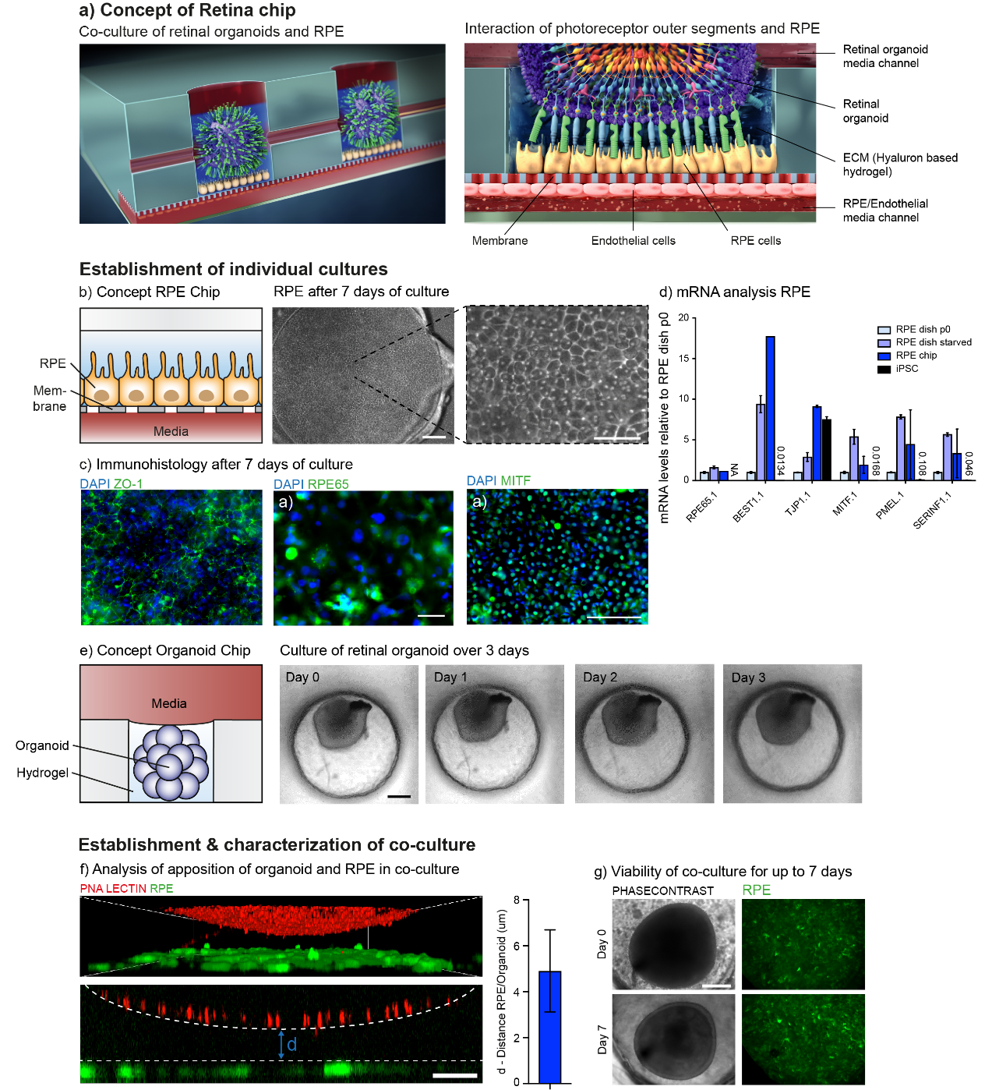

**Figure 1**: A) Schematic illustration of the *Retina-on-a-chip* integrating hiPSC-RPE and retinal organoids. B) After 7 days, hiPSC-RPE cultured inside the chip show typical cobblestone morphology and C) stain positive for critical markers such as ZO-1, RPE65 and MITF. D) mRNA analysis of i) dish cultured hiPSC-RPE p0, ii) after starvation for 14 days, and iii) of hiPSC-RPE inside the chip. Data were normalized to dish p0 culture expression. E) Mechanical fixation of a hiPSC-retinal organoid chip embedded in a hydrogel. No visible changes of morphology or viability after 3 days of culture. F) Establishment of co-culture Retina-on-a-chip: Organoid inner/outer segments were marked with PNA lectin before co-culture with GFP marked hiPSC-RPE. Mean distance between lectin positive segments and RPE was determined. G) Organoid and RPE exhibit no signs of degeneration after 7 days culture. Scale bars: b) 80 µm, c) f) 40 µm, e) g) 200 µm; Error bars = S.E.M

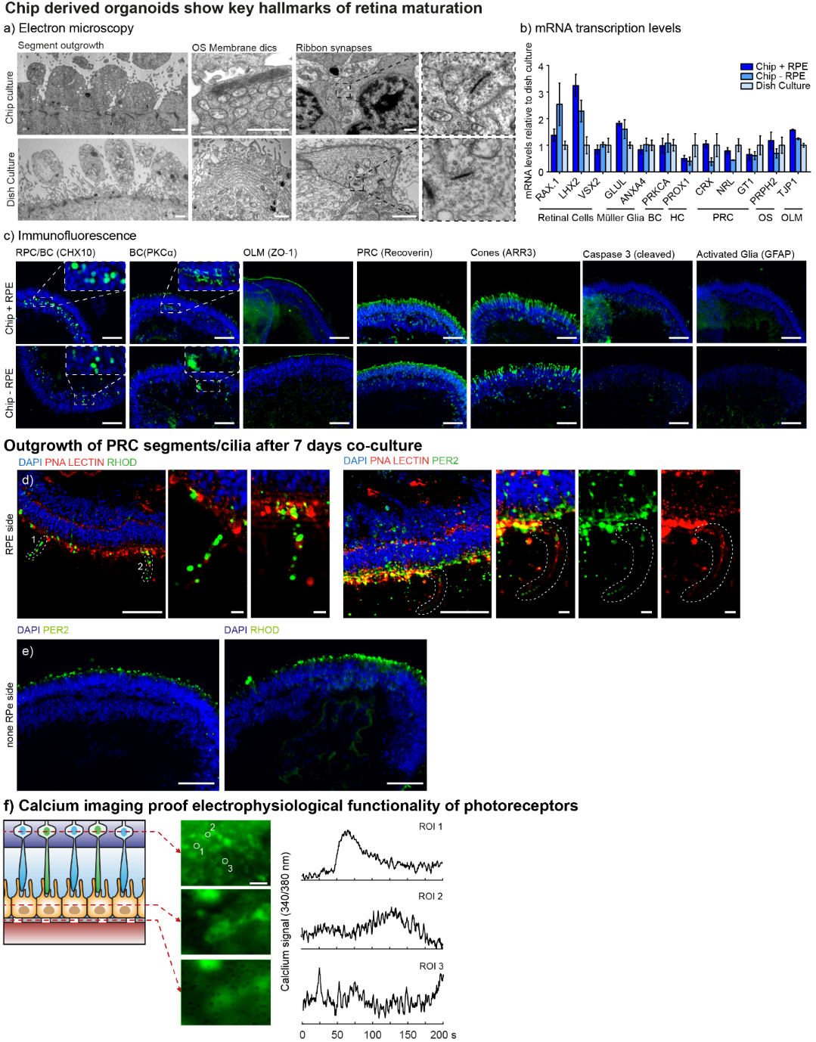

**Figure 2**: A) Electron microscopy of organoids after 3 days of on-chip culture reveals the key hallmarks from standard dish cultured organoids: Segment outgrowth, OS Membrane discs and ribbon synapses. B) mRNA expression from organoids with and without RPE culture for 3 days inside the chip were comparable to respective classically dish cultured organoids C) Retrieved organoids from co-culture chip with RPE and without RPE showed neither glia activation (GFAP) nor apoptosis (cleaved Caspase 3). All expected cell types and structures (Rods, cones, BC, OLM, IS/OS) were present. D) Photoreceptor cells facing towards the RPE layer displayed long outgrowing processes, positive for the outer segment markers Rhodopsin, Peripherin 2 and Lectin, which E) were not present at the non RPE side. F) For calcium imaging, co-culture chips were pre-incubated with Fura-2 dye and fluorescence was monitored for 200 s. Ratios of 340 nm/380 nm channels are shown. Three representative ROIs from photoreceptor cells in close apposition to RPE cells were depicted showing spontaneous calcium flux. Scale bars: a) 1 µm, c) 80 µm, d) 80 µm and 10 µm (magnification), e) 80 µm, f) 10 µm. Error bars = S.E.M.

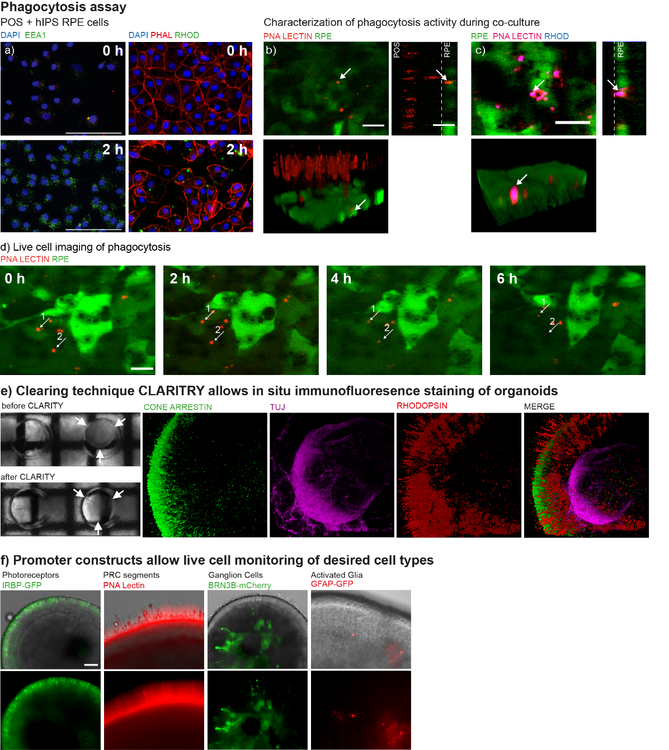

**Figure 3**: A) For phagocytosis assay, hiPSC-RPE were incubated with bovine photoreceptor outer segments (POS) and after 2 h stained positive for endosomal marker EEA1 (green, left images) and Rhodopsin (green, right images). B) In co-culture chips, PNA Lectin marked organoid segments could be found inside GFP labelled RPE cells and C) were co-stained for Rhodopsin(blue) after fixation. D) Live cell imaging of Lectin-punctae (e.g. 1 and 2) showed steady signal decrease within 6 h probably caused by lysosomal digestion. E) Clearing technique CLARITY was applied on retinal organoids inside the chip, which were imaged before and after the procedure showing the increase in transparency. E) Representative images of a cleared organoid stained with Cone Arrestin (green), TUJ (magenta) and Rhodopsin (red), taken by confocal microscopy and 3D-reconstructed. F) Promoter driven fluorophore constructs for photoreceptors (IRBP-GFP), ganglion cells (BRN3B-mCherry) and activated glia (GFAP) were lentivirally transfected. Photoreceptor segments were labelled by organoid incubation with PNA Lectin. Scale bars: a) d) 40 µm, b) c) 10 µm, e) 200 µm, f) 80 µm

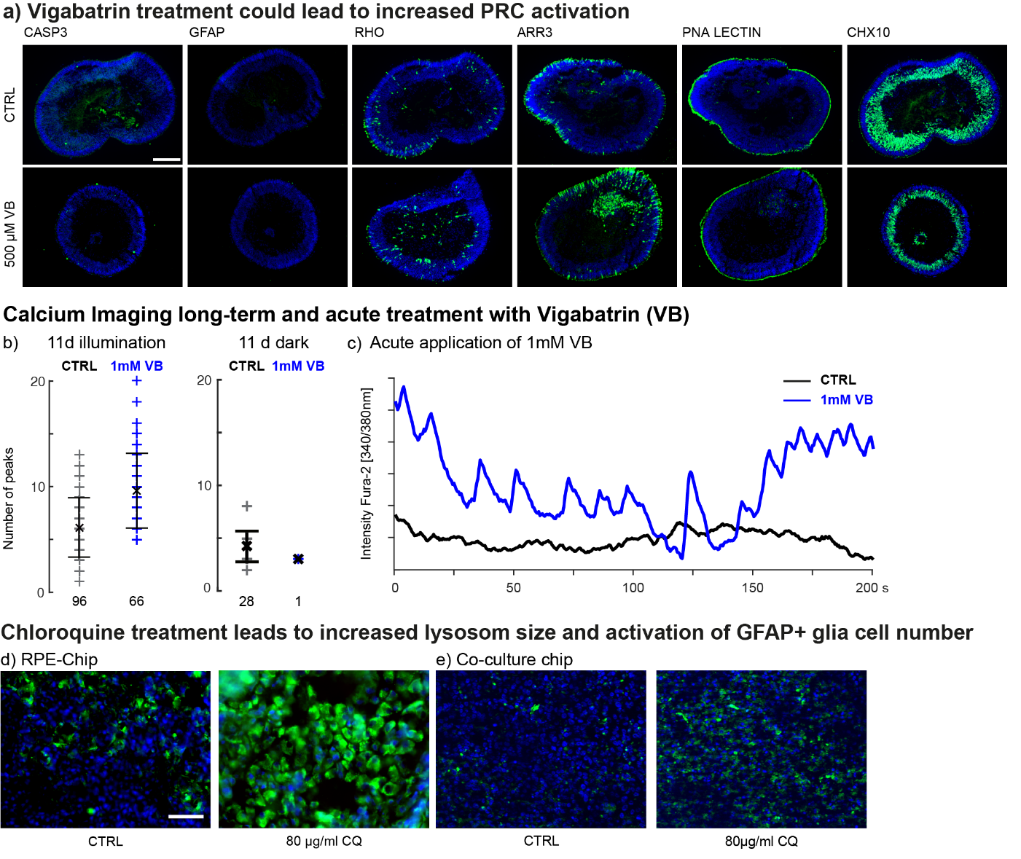

**Figure 4**: A) Dish cultured day 170 retinal organoids were treated for 20 days with 500 µM of Vigabatrin (VB). No morphological changes or signs of gliosis (GFAP) and apoptosis were observed using immunofluorescence. B) For calcium imaging, dish cultured organoids were treated with 1 mM of VB for 11 days in either constant illumination (left) or in the dark (right). Cells were loaded with Fura-2 dye and calcium dye fluorescence (340nm/380nm ratio) was measured for 200s. Each cross represents number of calcium peaks in one individual measured cell. C) Day 400 organoids were treated for 30 min with 1 mM VB and the mean activity of 4 measurements of one representative cell before (black line) and after treatment (blue line) was illustrated. Scale bars a) c) 200 µm, b) 80 µm. Error bars= S.E.M.